Software Design Specification
for
Mobile Exam & Grade Tracking System
Version 1.1 approved
Prepared by Team 1
26.04.2017
Table of Contents

1. Introduction 3
1.1. Document Outline 3
1.2. Document Description 4
1.2.1. Introduction 4
1.2.1.1 Purpose 4
1.2.1.2 Scope 5
1.2.1.3 Intended Audience 5
1.2.1.4 References 5
1.2.2. System Overview 6
1.2.2.1 Product Perspective 6
1.2.2.1.1 Design Method 6
1.2.2.1.2 User Interfaces 6
1.2.2.1.3 Hardware Interfaces 9
1.2.2.1.4 Software Interfaces 9
2. Design Considerations 9
2.1. Assumptions and Dependencies 10
2.1.1. Related Software or Hardware 10
2.1.2. End-User Characteristics 10
2.2. General Constraints 11
2.2.1. Hardware or Software Environment 11
2.2.2. End-User Environment 11
2.2.3. Availability or Volatility of Resources 11
2.2.4. Standards Compliance 11
2.2.5. Interoperability Requirements 11
2.2.6. Interface/Protocol Requirements 12
2.2.7. Data Repository and Distribution Requirements 12
2.2.8. Security Requirements 12
2.2.9. Memory and Other Capacity Limitations 12
2.2.10. Performance Requirements 13
2.2.11. Network Communications 13
2.2.12. Verification and Validation Requirements (Testing) 13
2.3. Goals and Guidelines 13
2.4. Development Methods 14
3. Architectural Strategies 14
4. System Architecture 16
4.1. Subsystem Architecture 26
5. Policies and Tactics 29
6. Detailed System Design 29
6.1. Classification 29
6.2. Definition 30
6.3. Responsibilities 30
6.4. Constraints 31
6.5. Composition 31
6.6. Uses/Interactions 35
6.7. Resources 35
6.8. Processing 35
7. Glossary 36
8. Bibliography 37

Introduction

The purpose of this software design document is to provide a low-level description of the MEGTS, providing insight into the structure and design of each component. Topics covered include the following:

• Class hierarchies and interactions
• Data flow and design
• Processing narratives
• Design constraints and restrictions
• Interfaces

In short, this document is meant to equip the reader with a solid understanding of the inner workings of the MEGTS.

Document Outline

Here is the outline of the proposed template for software design specifications.
- Introduction
  - Document Outline
  - Document Description
      - Introduction
      - System Overview
- Design Considerations
  - Assumptions and Dependencies
  - General Constraints
  - Goals and Guidelines
  - Development Methods
- Architectural Strategies
- System Architecture
  - System Architecture
  - Subsystem Architecture
- Policies and Tactics
- Detailed System Design
  - Classification
  - Definition
  - Responsibilities
  - Constraints
  - Composition
  - Uses/Interactions
  - Resources
  - Processing
  - Detailed Subsystem Design
- Glossary
- Bibliography

Document Description

Introduction

Purpose

This Software Design Specification (SDS) provides an overview of the proposed MEGTS project design. It will encompass in detail the basic outline of our project and represent a basis for the development process. This will also allow critical analysis of the logical and functional aspects of the design before any commitment is made to actual code. MEGTS tool is a tool that designed as a prototype to demonstrate the functionality of Cypher Block Chaning (CBC). We will also consider some additional security concerns during the design process.

Scope

This document details the design of MEGTS from multiple perspectives: architectural design, interface design . This is achieved through the use of architectural patterns, use caase diagrams, sequence diagrams, class diagrams.

Intended Audience
This document is mainly for the developers and the technical and academic staff of Eastern Mediterranean University of T.R.N.C. and student representatives of the University.

References

- IEEE Std 610.12-1990, IEEE Standard Glossary of Software Engineering Terminology. [1]
- IEEE Std 730-1998, IEEE Standard for Software Quality Assurance Plans.
- IEEE Std 828-1998, IEEE Standard for Software Configuration Management Plans.
- IEEE Std 830-1998, IEEE Recommended Practice for Software Requirements Specifications.
- Modern Systems Analysis and Design (8th Edition) - Valacich & George
- Freeman, P. and A. I. Wasserman, Tutorial on Software Design Techniques. 4th Edition, IEEE Computer Society Press, Annotated Bibliography, pp. 715–718, 1983.

System Overview

Product Perspective

This product gives chance to see all of course materials about relevant courses and grades of exams. It takes informations from instructors and shows them to students. It also has administrator management and instructor panel.

Design Method

The design of this product utilizes an object-oriented approach, access control models and CBC encryption for security.

User Interfaces

The user of this software product will be interfacing with a system like student portal but it has more opportunities and details. It also has mobile view which gives chance to track everything with mobile devices. The product allows the user to get informations directly and with no delay and detailed. Sample user examples are shown below.

Sample User Interface #1:
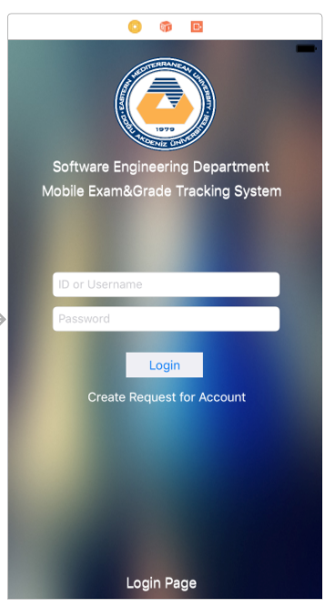
Sample User Interface #2:

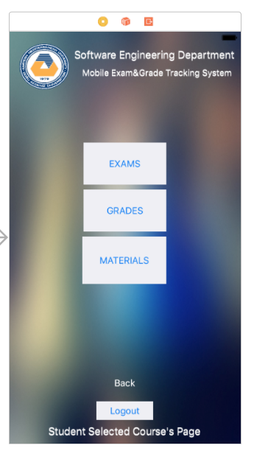
Sample User Interface #3:

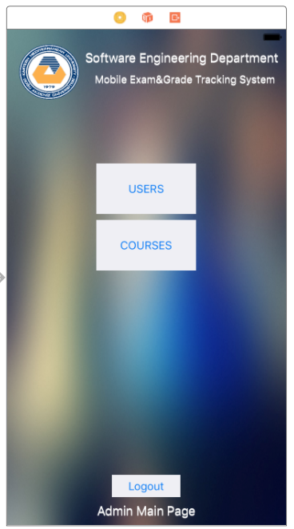

Sample User Interface #4:

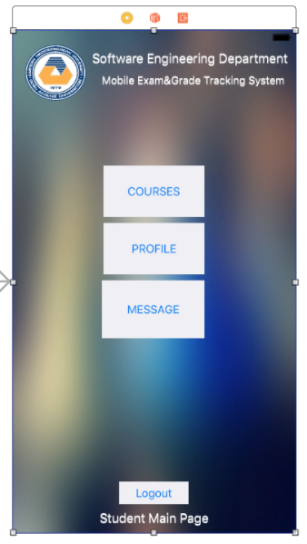

Hardware Interfaces

This tracking software can run on most Apple devices which has opportunity to run iOS operating system and decided versions, hardwares and enough specifications.

Software Interfaces

This system will compile code on a Apple MacOSX platform XCode compiler and work properly on iOS mobile operating system of Apple’s.

Used tools are listed below when preparing documents.

- Microsoft Word : This tool is used for preparing written documents in profession.
- Visual Paradigm : VP tool is used when drawing an preparing diagrams.
- Github : Github is used to work easy with team members. All project documents have been uploaded github.
- Xcode and Sketch : Xcode will be used for coding and compiling. In this step of project Xcode used to implement the designed interfaces from Sketch to application.
- Microsoft Project : MS Project is a project management tool and it is used to prepare our workflows of project and they mentioned in proposal of project.
- Microsoft Excel : MS Excel is used to prepare tables for documents.

Design Considerations

This section describes many of the issues which need to be addressed or resolved before attempting to devise a complete design solution.

Assumptions and Dependencies

AS-1: The system shall support all of users at the same time.
AS-2: The system shall not lock the DB when working.
AS-3: The system shall provide warnings when wrong processes are happening.
AS-4: The system will be online for 7 hours/24 days.
AS-5: All calculations and information sections must be in right place.
AS-6: The system shall have limitations to user types.

Related Software or Hardware

This program will be coded in XCode on MacOSX operating system. We will be using Swift 3 language and CoreData and MySQL for databases. CoreData and MySQL servers creates some connection or query errors that need to be researched and fixed if this is the preferred environment.

End-User Characteristics

User - The users for the MEGTS. User contains instructors and students.

Administrator - One of the users of the MEGTS. This users creates/deletes/edits users,
courses, informations from database. Administrator also has chance to set
permissions of users.

Internet - The internet connection of the user’s device to be able to use the MEGTS.

General Constraints

Hardware or Software Environment

There is a web server requirement to store and retrieve data. Local CoreData and online MySQL are the preferred database types due to the security and stability requirements. Also CBC encryption method will be used on these databases.

End-User Environment

Administrator and user should have internet connectivity and iOS devices. They will need to
login with their user credentials to be able to use the MEGTS.

Availability or Volatility of Resources

This depends on the internet connection and convenient device. All of the processes will be
done via online. Stability and availability can be measured with the number of failures on the
internet connection.

Standards Compliance

Software Engineering Standards Committee of the IEEE Computer Society, “IEE Recommen-ded Practice for Software Design Descriptions”, IEE Std 1016-1998.

Interoperability Requirements

The following are interoperability requirements of MEGTS:

- The application shall properly interoperate with the database.
- The application shall properly interoperate with the existing student portal and its applications.
- The application shall properly interoperate with MySQL/Oracle server of university.

Interface/Protocol Requirements

Internet connectivity and TPC/IP support are main requirements.

Data Repository and Distribution Requirements

Data will be stored in the database and Web services will be used to store the encrypted data. Stored processes will be used in some functions. By doing all the connections via stored processes can limit the access to the databases to the stored processes level.

Security Requirements

CBC will be used. It is important to have a secure data storing, user credentials. Also, system
will be needed to use SSL connection between web services of database and application.

Memory and Other Capacity Limitations

There is no limitations about memory and capacity. iOS 9 and 10 will be supported. So, All iOS 9 and 10 devices will be support MEGTS.

Performance Requirements

No internal failures are acceptable. The only known and accepted failures are from the Internet connection that is providing the communication between the database and devices.

Network Communications

Network should be up all the time as part of the functionality is to be able to use the e-voting tool on the network or internet.

Verification and Validation Requirements (Testing)

Between DB and device, there will be required to be able to test and verify the internet functionality and compability.

Goals and Guidelines

The major goal of the MEGTS is that it be extremely simple and intuitive to use. The application is geared towards the easy usability of university student systems. It is very important that the prompts for the user be clear and concise since this will be the highest level of interaction between the application and the user. It is also important that series of prompts and responses be tested with users before being deployed as part of the product so that all interaction is “approved” by a potential user.

The MEGTS application is intended to have a simple interface that is relatively easy to administer. A minimal yet complete set of options is provided for the administrator to have control of users or informations. This also intended to have a simple user interface that gives easy usability to students and instructors to follow every information about exams and grades with mobile devices which has iOS operating system by Apple.

Development Methods

The chosen method/model to developing MEGTS is waterfall model. Due to the small size of the project, waterfall is easy to apply. Also, OOP development method is used to develop.

Reasons of using of object oriented software development methods:
• Improved software maintainability.
• Faster development
• Lower cost development
• Improved software development productivity
• Higher quality software

Architectural Strategies

The architecture and design has been influenced by the following design decisions and strategies:
- The design shall use Object Oriented Principles (OOP). The trade-off of increased code overhead and object message passing is considered justified by the gain of modularization of functionality, data encapsulation, communication through interfaces and re-use through polymorphism. In addition, the entire team is familiar with this paradigm and a design of this type will facilitate communication amongst the developers.
- Entry points for web services to create JSON will be standard PHP code constructs but will immediately transition to OOP PHP functions with queries to reach DB datas. This is the compromise in a language that is still transitioning to full OOP functionality.
- The overall system is designed upon a client-server approach. This is an established and well-understood architecture and presents no problems to the team.
- Authentication will be limited to password checking on initial login and a session ID subsequently. This is considered sufficient to the low risk nature of the data.
- The DB will be shared by the system. There is no direct interface between these systems so concurrency will be handled by the JSON queries with PHP. It will be necessary to not lock the database in such a way.
- Details of sessions, templates and user accounts will reside in the DB. Access to this data will be easier and more secure than creating files on file system.
- Communication with the users will be by the system protocols as this is well-supported by the selected connection of system and PHP.
- PHP-JSON and MySQL were selected because they had the necessary capabilities to provide the needed services to the user and their GNU licenses will reduce product cost.
- The system is meant to be modifiable:
  - By the use of new pre-defined templates created as well as the end-customer.
  - By having the system adapt to additional fields added to the database schema to established tables defined.

System Architecture

System Architecture Context Diagram:

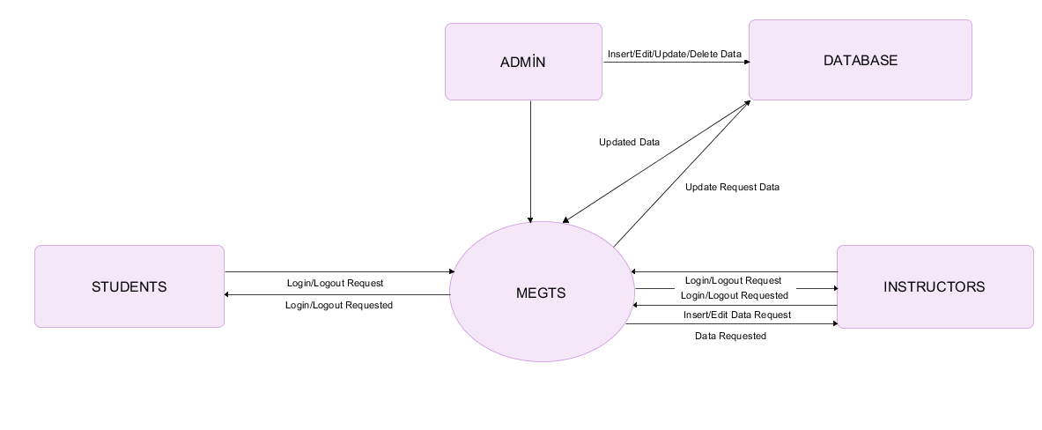

BPMN Diagram of Uploading Material Event:

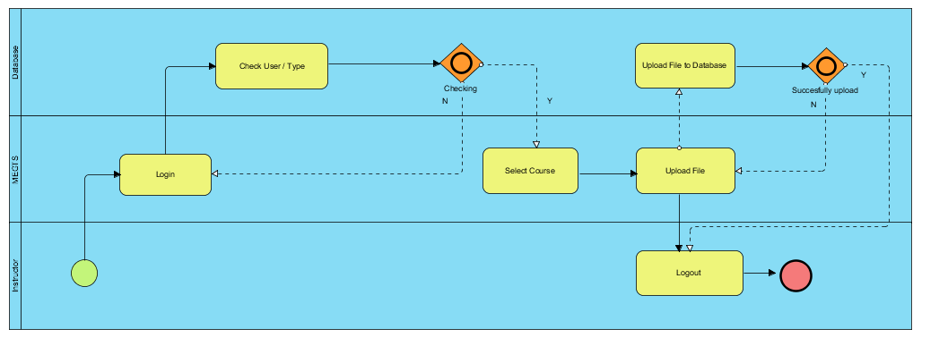

General Activity Diagram:

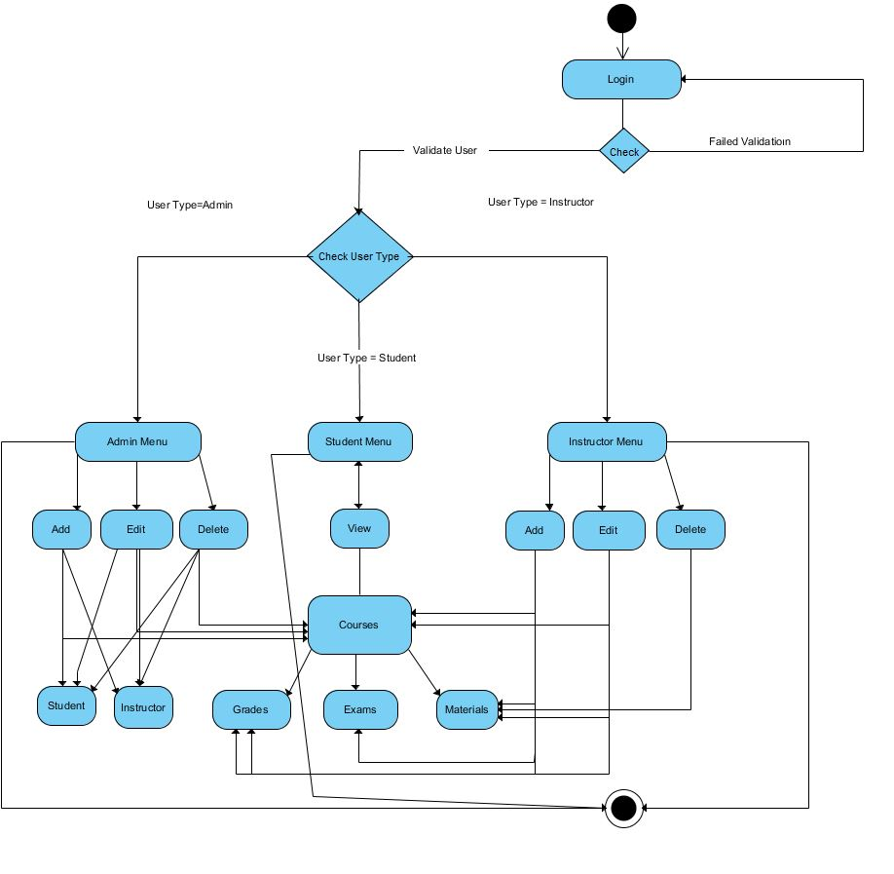

Entity-Relationship Diagram (Mandatory Model) :
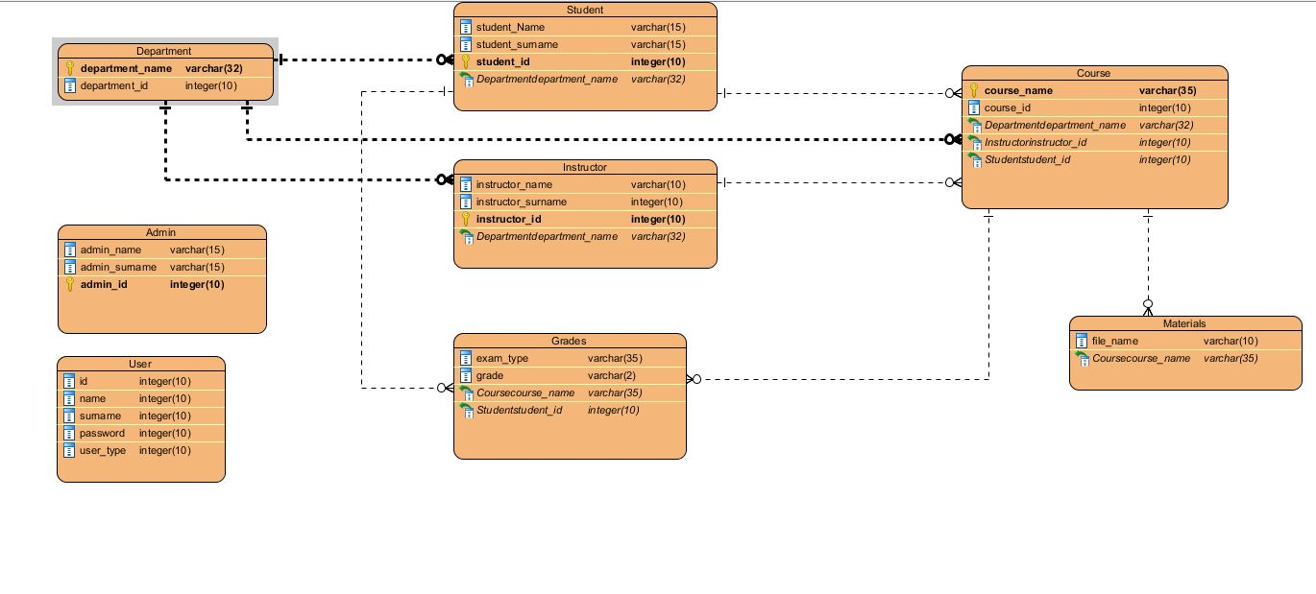
Level-0 Data Flow Diagram:

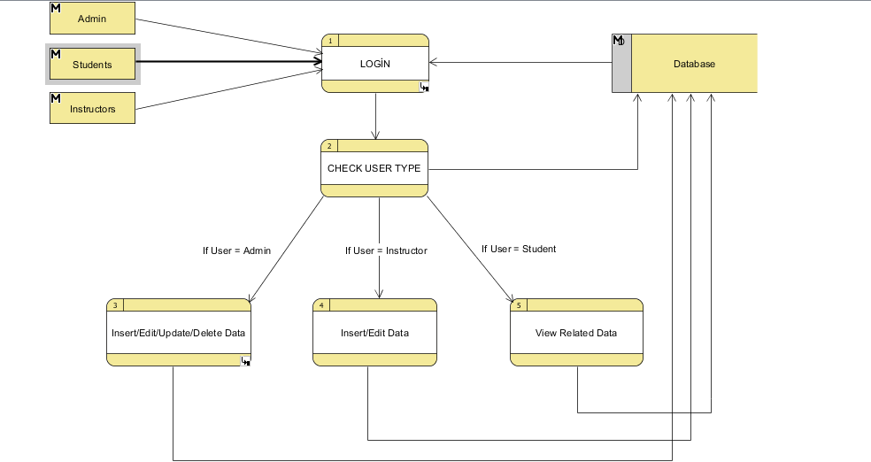

Use Case 1 Specification:

Use Case ID: | 1
Use Case Name: | MEGTS Instructor Use Case
Created By: | Group 1 | Last Updated By: | Group 1
Date Created: | 22/04/2017 | Date Last Updated: | 25/04/2017

Primary Actors: | Instructor
Secondary Actors: | -
Description: | This use case describes how to access to system pages by instructor.
Trigger: | Instructor will need to login to the system to use transactions.
Preconditions: | Actor Network is idle. Actor internet is idle. Actor Database is idle. Instructor has username and password assigned.
Postconditions: | -
Normal Flow: | Instructor logs in and connects to the instructor main page where s/he will have access to use system. Connect to this via actor internet. Connect to the database via actor database. Instructor will choose one of the profile,courses, students or received messages buttons from the list and open relevant page. When opens new page, instructor again will have chance to manage students, upload course materials or enter grades.
Alternative Flows: | None.
Exceptions: | Network and database connectivity issues.
Priority: | High
Frequency of Use: | High
Business Rules: | None
Special Requirements: | Any instructor that has login credentials setup by the admin will have access to the student main page.
Open Issues | None
Assumptions: | Instructor has internet connection and user credentials setup.
Notes and Issues: | Any internet connection or network connection issue will cause access problems to the MEGTS.

Use Case #1 Diagram:

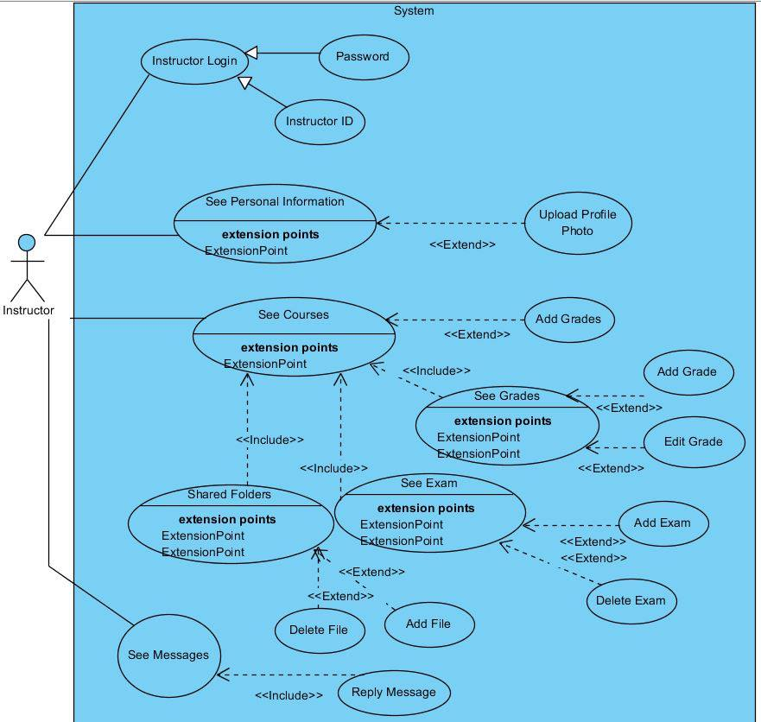
Use Case 2 Specification:

Use Case ID: | 2
Use Case Name: | MEGTS Student Use Case
Created By: | Group 1 | Last Updated By: | Group 1
Date Created: | 22/04/2017 | Date Last Updated: | 25/04/2017

Primary Actors: | Student
Secondary Actors: | -
Description: | This use case describes how to access to system pages by student.
Trigger: | Student will need to login to the system to use transactions.
Preconditions: | Actor Network is idle. Actor internet is idle. Actor Database is idle. Student has username and password assigned.
Postconditions: | -
Normal Flow: | Student logs in and connects to the student main page where s/he will have access to use system. Connect to this via actor internet. Connect to the database via actor database. User will choose the courses, profiles or message buttons from the list and open relevant page.
Alternative Flows: | None.
Exceptions: | Network and database connectivity issues.
Priority: | High
Frequency of Use: | High
Business Rules: | None
Special Requirements: | Any student that has login credentials setup by the admin will have access to the student main page.
Open Issues | None
Assumptions: | Student has internet connection and user credentials setup.
Notes and Issues: | Any internet connection or network connection issue will cause access problems to the MEGTS.

Use Case #2 Diagram:
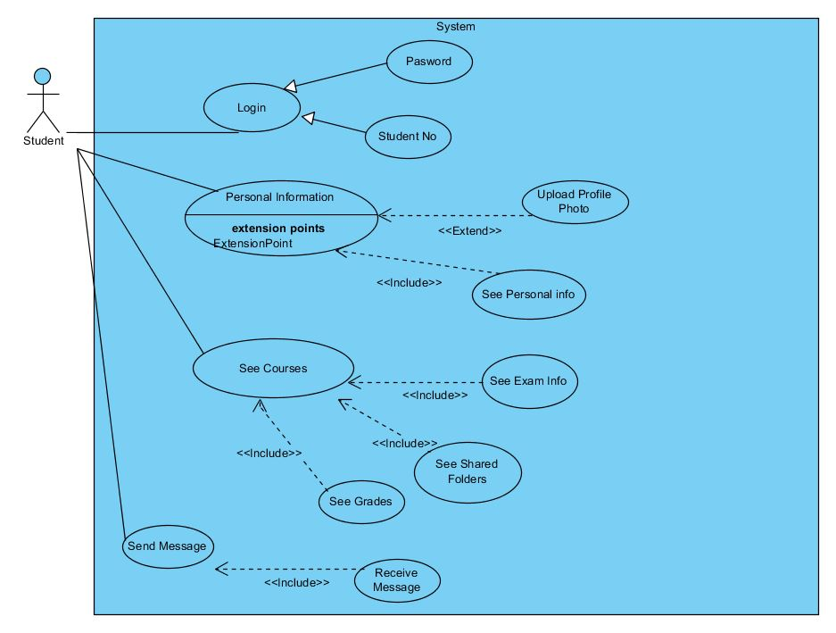

Use Case 3 Specification:

Use Case ID: | 3
Use Case Name: | MEGTS Student Use Case
Created By: | Group 1 | Last Updated By: | Group 1
Date Created: | 22/04/2017 | Date Last Updated: | 25/04/2017

Primary Actors: | Administrator
Secondary Actors: | -
Description: | This use case describes how to access to system and management pages by administrator.
Trigger: | Administrator will need to login to the system to manage accounts/courses/informations.
Preconditions: | Actor Network is idle. Actor internet is idle. Actor Database is idle. Administrator has username and password assigned.
Postconditions: | -
Normal Flow: | Administrator logs in and connects to the admin main page where s/he will have access to manage system and informations. Connect to this via actor internet. Connect to the database via actor database. Admin will choose the courses or users buttons from the list and open relevant page. Admin will have chance to add/delete/edit options to many pages in system.
Alternative Flows: | None.
Exceptions: | Network and database connectivity issues.
Priority: | High
Frequency of Use: | High
Business Rules: | None
Special Requirements: | Any admin that has login credentials setup by the department of university will have access to the admin main page.
Open Issues | None
Assumptions: | Administrator has internet connection.
Notes and Issues: | Any internet connection or network connection issue will cause access problems to the MEGTS.

Use Case #3 Diagram:
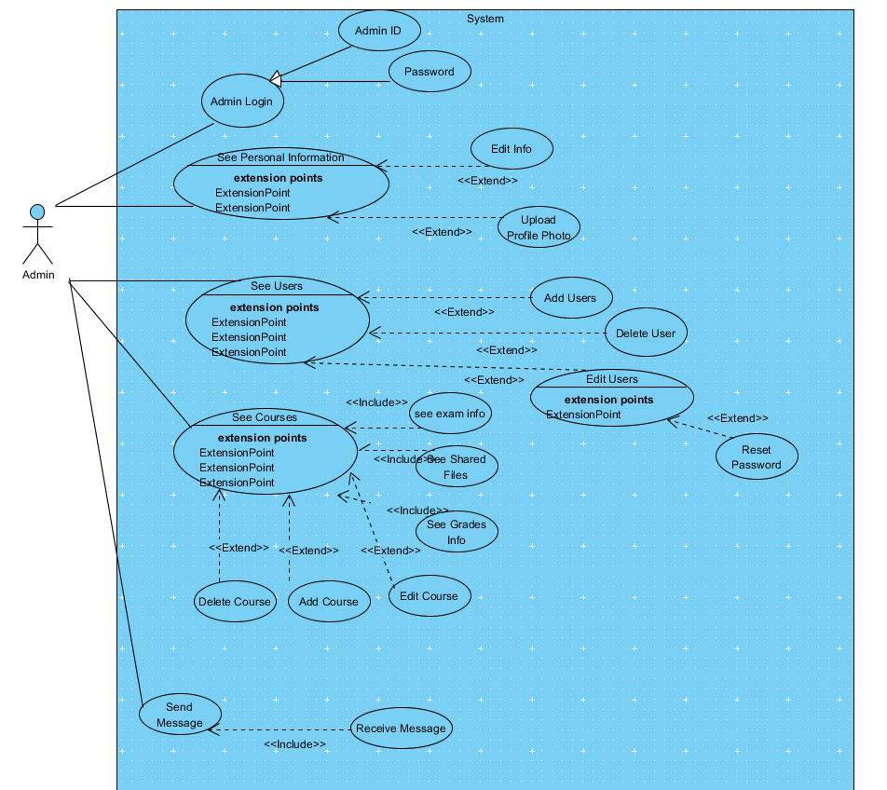

Sequence Diagram #1 (Login Event) :

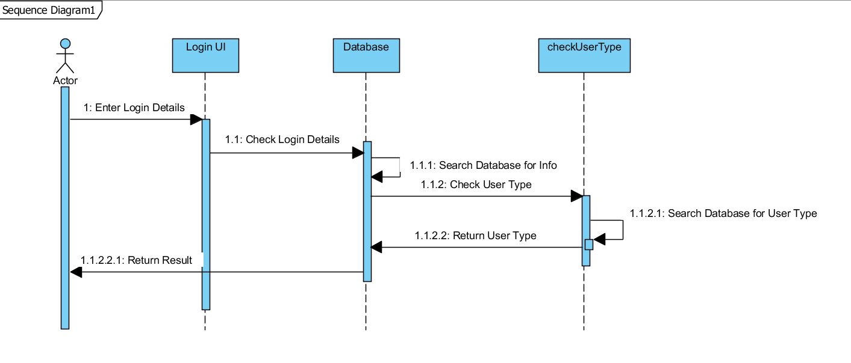
Sequence Diagram #2 (Adding Student Event) :

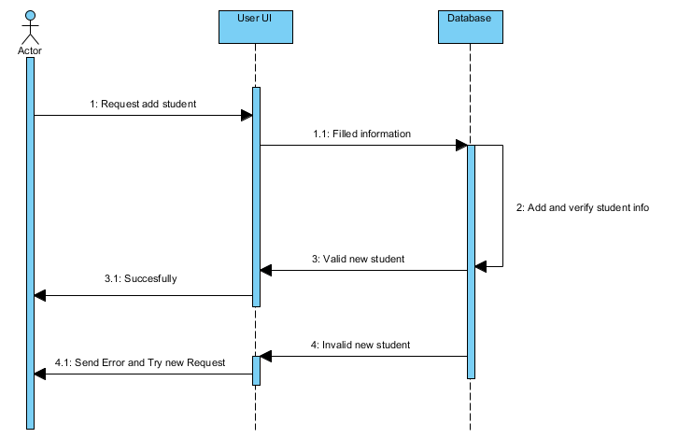

Subsystem Architecture

In this section, there will be some example diagrams of subsystem’s basics. These diagrams will be helpful to see how system’s pieces works.

Admin – Subsystem Simple Use Cases #1 Diagram:

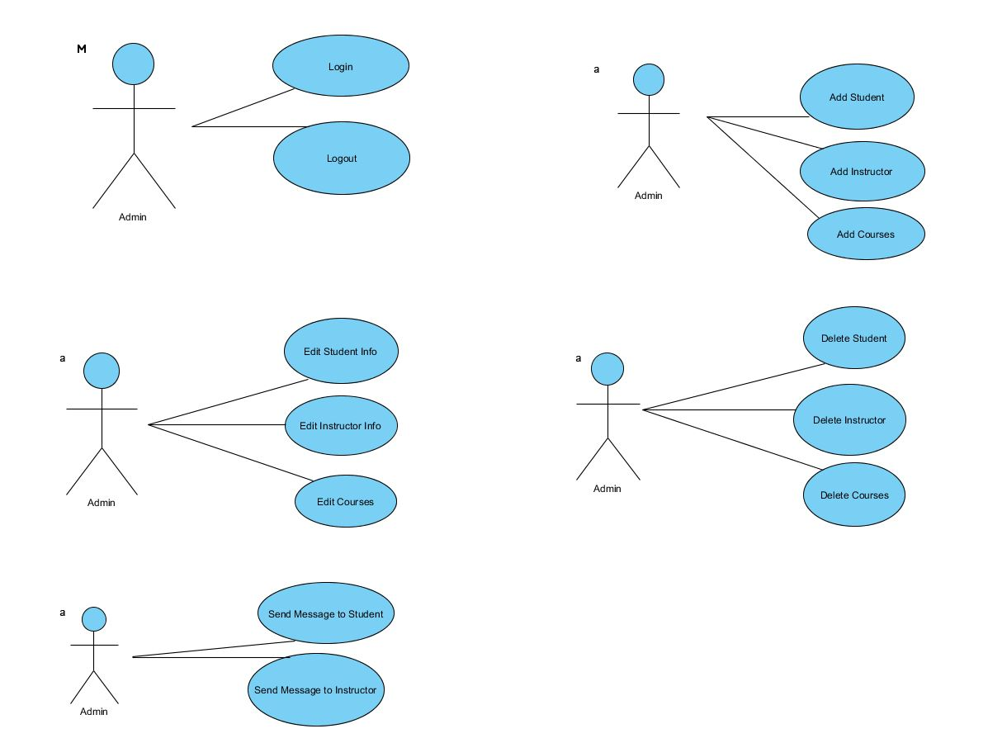
Instructor – Subsystem Simple Use Cases #2 Diagram:

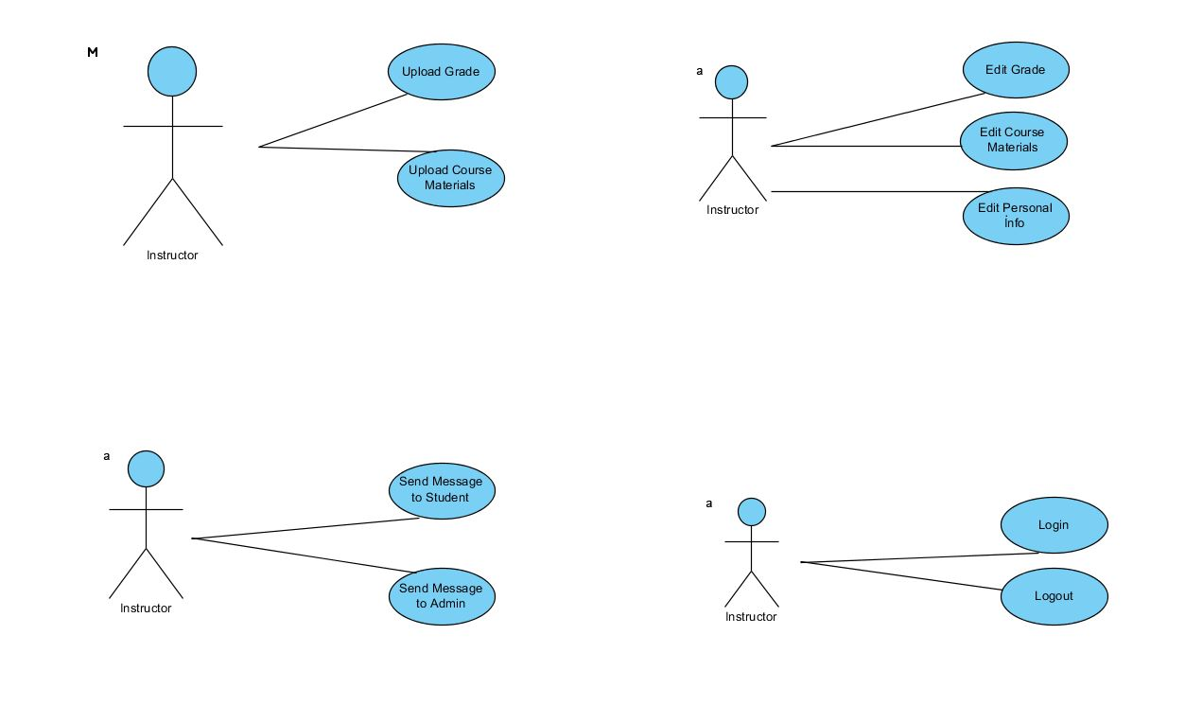

Student – Subsystem Simple Use Cases #3 Diagram:
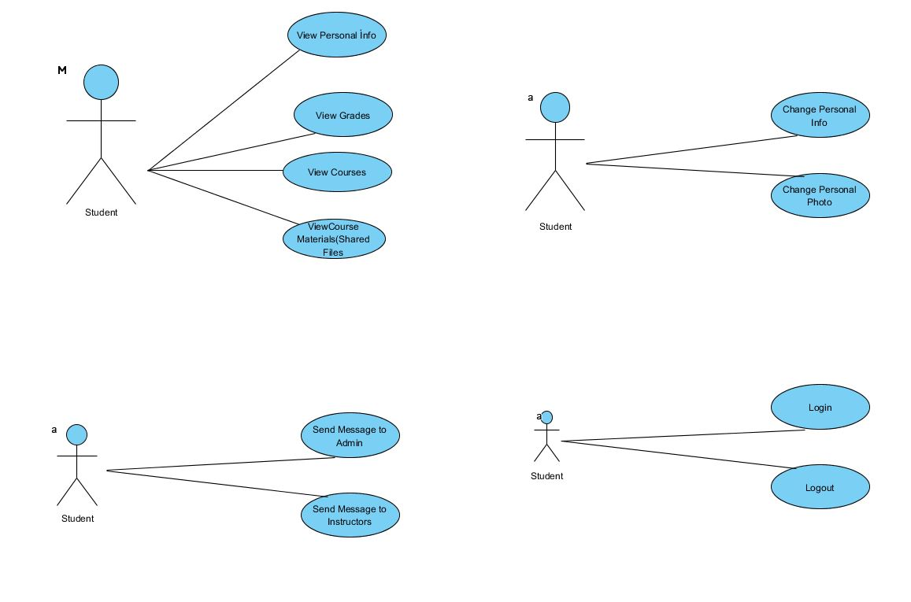

Policies and Tactics

It will be coded in Swift 3 language with XCode on MacOSX operating system. Design Patterns will be used in the development. Visitor and State Desing patterns will be applied on some of the modules. TCP/IP network communication and SSL needs to be established for network module design. It will be an online application where internet connection will be required. Visitor and State Desing patterns will be applied on some of the modules. Strategy desing pattern can also be used. SRS document was provided and all the requirements specified in the document have been applied in the design. Also use cases are created to make sure that all the functionality will be defined in the functions according to the requirements. All the features set and needed requirements need to be tested with the scenarios created. An additional test document will be provided. Every bugs will be reviewed. Any reported problems will be fixed. This document will need to be updated if there are any new additional requirements involved. MEGTS will require end-users to have internet access, user login credentials, iOS supported devices. They all need to be setup as a virtual web server. More details need to be provided in the setup documents for the users. Program will be compiled from the development machine and placed into the web server. XCode is the main developing application required to be able to code this application. Also, A running MySQL supported web server will be required.

Detailed System Design

The MEGTS is done with Data Flow diagram below. This DFD is created from the SRS document provided. Detailed diagrams will be provided with reports.

Classification

Class diagram is drawn below for the classes used in this project. Operations and attributes are defined for each class.

Class Diagram #1:

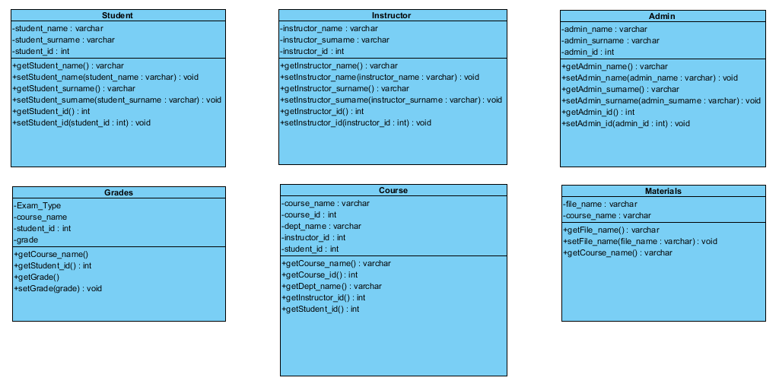

Definition

The specific purpose and semantic meaning of the component are above. All the requirements are drawn in these diagrams to make it clear for the developer. For additional functionalities main level is divided into sub levels.

Responsibilities

The primary responsibilities and/or behavior of the forms are:

User Login Form : This is the login form. Login credentials will be provided by the administrator. According to the login credentials users will be connected either to the administrator, instructor or student pages.

Message Form : This form will be accessible by the users. They will be able to create the message through this form to admin or instructor.

Courses Form : This form also can be accessed by the administrators, instructors or students. Administrator can create/edit/delete courses for the system. Students only can view to courses or relevant transactions. Instructors have students’ similar permissions and like an addition can add material, exam informations or grades of courses.

Constraints

There won’t be any constraints on completing this project. It will be completed on time. Only unexpected errors can delay the project time to finish.

Composition

The composition of MEGTS project is shown below by data flow diagrams

Data Flow Diagram #1:

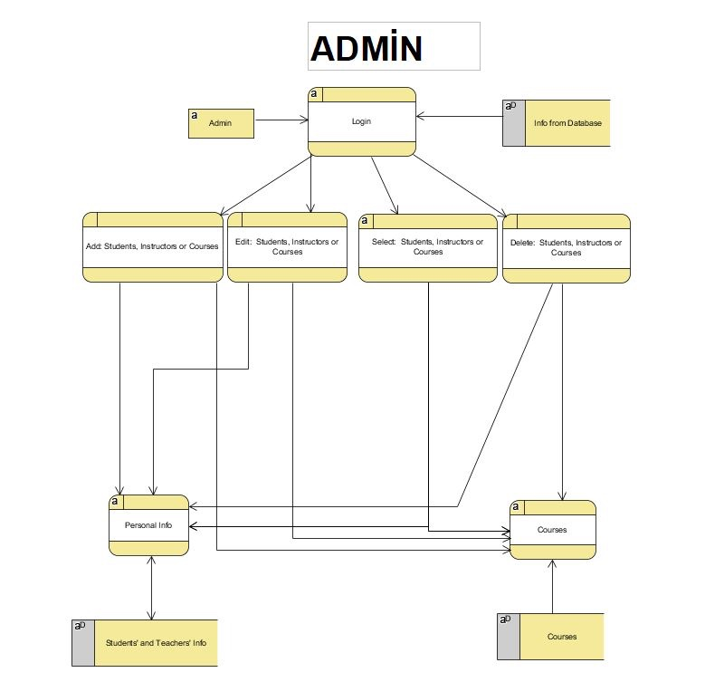

Data Flow Diagram #2:

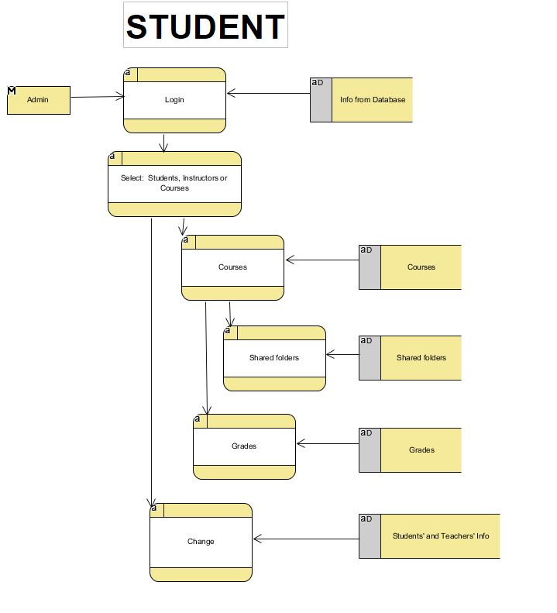

Data Flow Diagram #3:

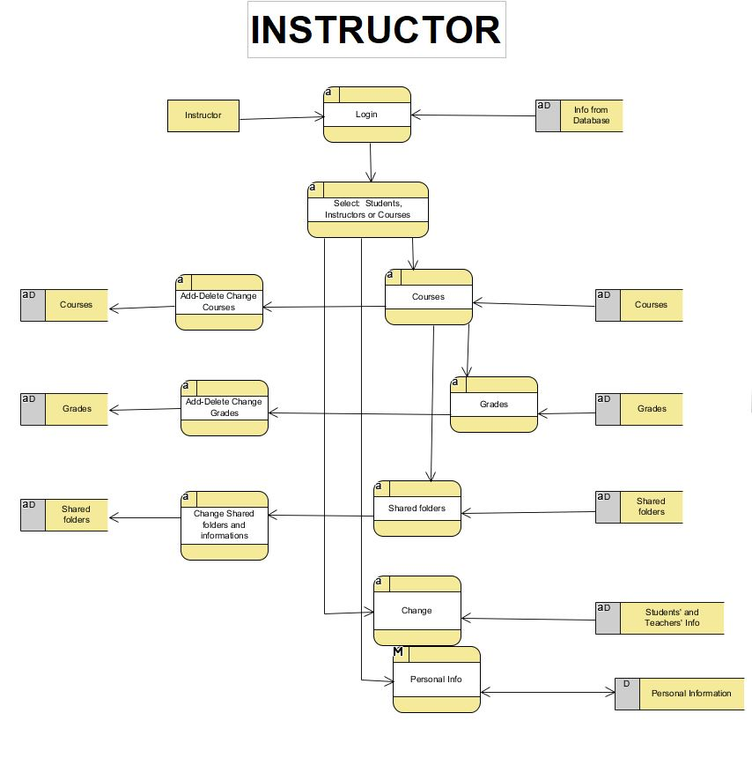

Uses/Interactions

The interactions between the classes are defined in the class diagrams drawn below.
.

Resources
The main resource is a server. Most of the functions will be running from the server and managed through the server. All transactions’ files or informations will be saved in JSON format on the server. When retrieving datas from database, there will be used server which has PHP and MySQL support to use JSON format.

Processing

Handling of exceptional conditions should be done in each module. All the scenarios that can cause errors need to be handled and not cause applications to crash. Error detection and recovery will be done. To be able to separate error-handling code from the regular code, we will add exception errors like do-catch method in the code. For example, use the following to print the stack trace.

do{ //processes }
catch (Exception e) { print(error) }

//General exception handler. This code will print the output of errors. [2]

Glossary

SRS : A software requirements specification (SRS) is a description of a software system to be developed. It lays out functional and non-functional requirements, and may include a set of use cases that describe user interactions that the software must provide. [3]

SDS : A software design description (a.k.a. software design document or SDD/SDS) is a written description of a software product, that a software designer writes in order to give a software development team overall guidance to the architecture of the software project. [4]

DFD : A data flow diagram (DFD) is a graphical representation of the "flow" of data through an information system, modelling its process aspects. [5]

GUI : The graphical user interface (GUI ), is a type of user interface that allows users to interact with electronic devices through graphical icons and visual indicators. [6]

GNU : GNU is composed wholly of free software, most of which is licensed under the GNU Project's own GPL. [7]

DB : A database is an organized collection of data. It is the collection of schemas, tables, queries, reports, views, and other objects. [8]

XCode : Xcode is an integrated development environment for macOS containing a suite of software development tools developed by Apple for developing software for macOS, iOS, watchOS and tvOS. [9]

iOS : iOS (formerly iPhone OS) is a mobile operating system created and developed by Apple Inc. exclusively for its hardware. It is the operating system that presently powers many of the company's mobile devices, including the iPhone, iPad, and iPod Touch. [10]

JSON : In computing, JavaScript Object Notation or JSON, is an open-standard format that uses human-readable text to transmit data objects consisting of attribute–value pairs. [11]

PHP : PHP is a server-side scripting language designed primarily for web development but also used as a general-purpose programming language. [12]

MEGTS: Mobile Exam&Grade Tracking System.Project name which refers to the overall project.

Bibliography

A list of referenced and/or related publications.

- Software Design Template, by Brad Appleton
- [1] IEEE publications are available from the Institute of Electrical and Electronics Engineers, 445 Hoes Lane, P.O. Box 1331, Piscataway, NJ 08855- 1331, USA (http://standards.ieee.org/).
- [2] The Swift Programming Language (Swift 3.1): Error Handling",Developer.apple.com, 2017. [Online]. Available: https://developer.apple.com/library/content/documentation/Swift/Conceptual/Swift_Programming_Language/ErrorHandling.html. [Accessed: 22- Apr- 2017].
- [3] Software requirements specification", En.wikipedia.org, 2017. [Online]. Available: https://en.wikipedia.org/wiki/Software_requirements_specification. [Accessed: 22- Apr- 2017].
- [4] "Software design description", En.wikipedia.org, 2017. [Online]. Available: https://en.wikipedia.org/wiki/Software_design_description. [Accessed: 22- Apr- 2017].
- [5] Data flow diagram", En.wikipedia.org, 2017. [Online]. Available: https://en.wikipedia.org/wiki/Data_flow_diagram. [Accessed: 22- Apr- 2017].
- [6] "Graphical user interface", En.wikipedia.org, 2017. [Online]. Available: https://en.wikipedia.org/wiki/Graphical_user_interface. [Accessed: 22- Apr- 2017].
- [7] "GNU", En.wikipedia.org, 2017. [Online]. Available: https://en.wikipedia.org/wiki/GNU. [Accessed: 22- Apr- 2017].
- [8] "Database", En.wikipedia.org, 2017. [Online]. Available: https://en.wikipedia.org/wiki/Database. [Accessed: 22- Apr- 2017].
- [9] "Xcode", En.wikipedia.org, 2017. [Online]. Available: https://en.wikipedia.org/wiki/Xcode. [Accessed: 22- Apr- 2017].
- [10] "IOS", En.wikipedia.org, 2017. [Online]. Available: https://en.wikipedia.org/wiki/IOS. [Accessed: 22- Apr- 2017].
- [11] "JSON", En.wikipedia.org, 2017. [Online]. Available: https://en.wikipedia.org/wiki/JSON. [Accessed: 22- Apr- 2017].
- [12] "PHP", En.wikipedia.org, 2017. [Online]. Available: https://en.wikipedia.org/wiki/PHP. [Accessed: 22- Apr- 2017].

